# The story of a girl named Ruth

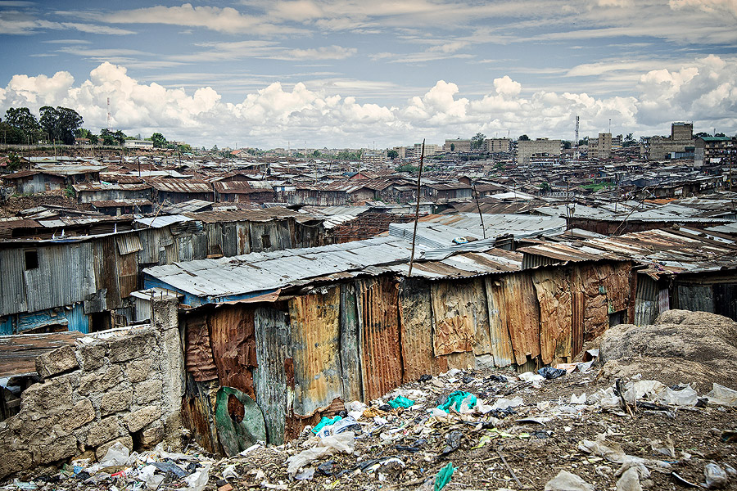I am Ruth, I live in Mathara Valley. This is the largest slum in the country. We have built our house themselves out of cardboard, corrugated iron and other waste. We do not have much money. I am a footballer at Mathara united, the football team of our slum. 14,000 children play football there. Rich countries like the Netherlands have created a field for us and paid goals. Here we can play football without us having to pay anything. In football, I can earn points by winning matches. But also by joining other actions you can earn points. For example by cleaning up the streets or by providing information about AIDS. AIDS is a big problem in our country. Many people die from this disease. When I collect enough points I can win a prize. A few weeks ago I won such a prize. Now I can go to school for free. My brother can also go to school for free.

Mathara valley = naam van de krottenwijk

Slum = krottenwijk

Country= land

Themselves = zelf

Cardboard = karton

Corrugated iron = golfplaten

Waste = afval

Disease = ziekte

Paying = betalen

Earn = verdienen

Matches = wedstrijden

Joining = meedoen

For example = bijvoorbeeld

Cleaning = schoonmaken

Providing information = voorlichting geven

Collect = verzamelen